QUIZ RESULTS
MODULE1: INRODUCTION TO UNSUPERVISED LEARNING AND K MEANS

No. | Quiz title | Completion Status | Score | Coursera link
1 | Module1_1_Introduction to Unsupervised Learning | Completed | 100% | Quiz 1
2 | Module1_2_K Means Clustering | Completed | 100% | Quiz 2
3 | Module1_3_Module 1 Quiz | Completed | 100% | Quiz 3

Module1_1_Introduction to Unsupervised Learning
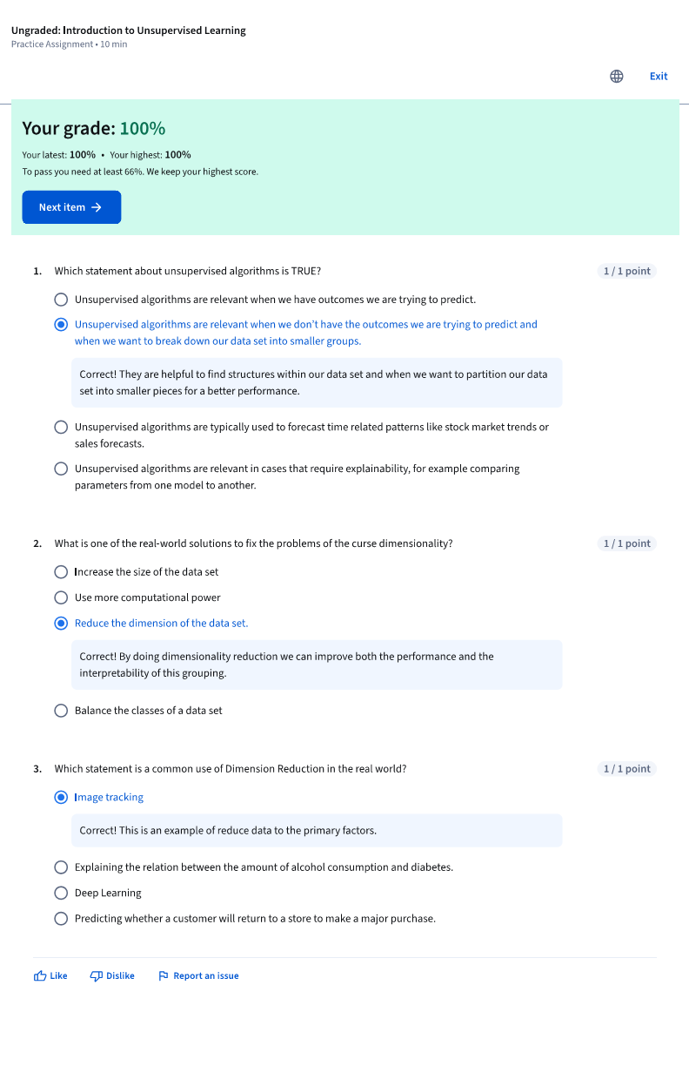

Module1_2_K Means Clustering
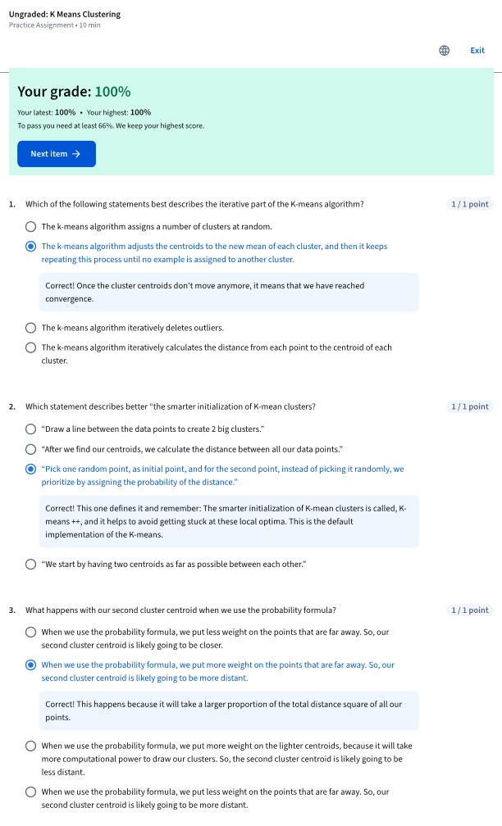

Module1_3_Module 1 Quiz
